***Game design* *document***

Finding destination

Contents

Genre

Platforms

Target

Concept

Reference

Game goal

Story synopsis

Premise

Theme

Sitting

Character design

Character artboard

Background

Character profile worksheet

Physical appearance

Intellectual / mental / personality / attitude

Prop design

Gameplay

Game play audio sound

Structure

Usability

Rules

Challenges

Challenge difficulty

Balance

Victory conditions

Core game play

Mechanics

Core mechanics

Level design

User interface

Genre: Puzzle Platformer

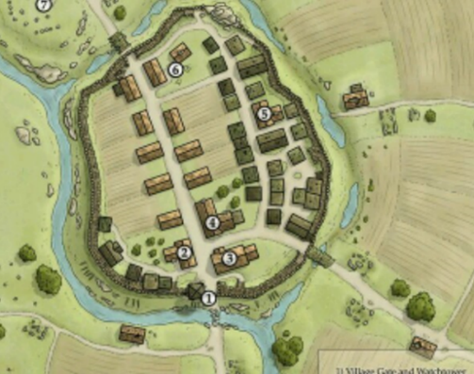

Platform: Mobile device (Android and IOS)



**Game Description**

Target: Primary target (10-25) years

Secondary target (25-40) years

Concept: Find out lost friends and rescue them.

Reference: Temple run

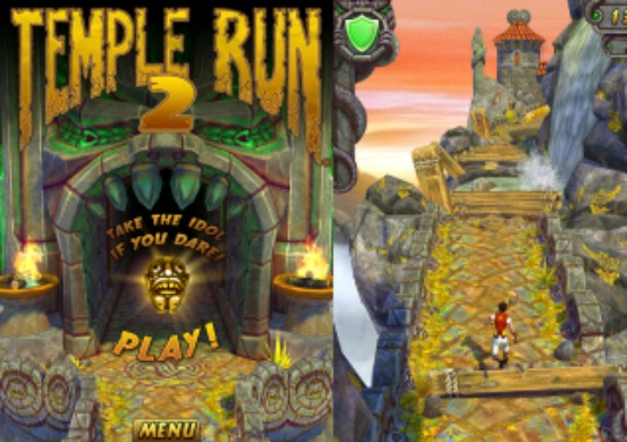

Character visual look:

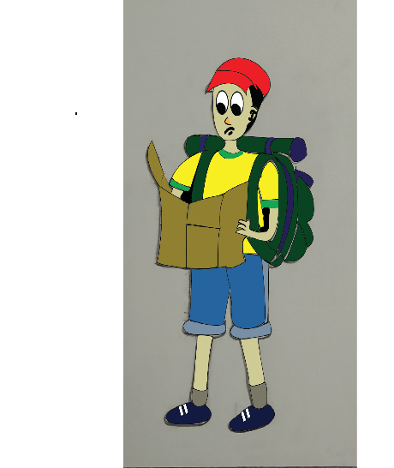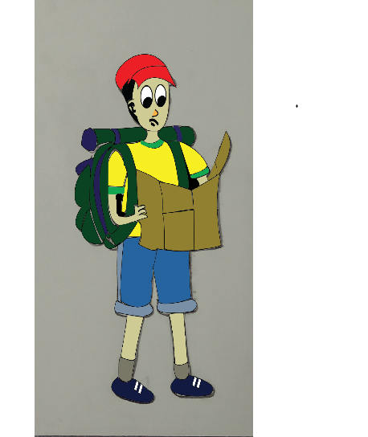

. Left side Right side

Game goal: Entertainment

Game story:

once there was an adventure loving boy. His name was Hendrie. He used to live in a small village. He had some friends. One day he and his friends decide to go on an adventure trip. After going to the trip his friends got separated from him because of an accident.

Synopsis:

Finding destination is a puzzle platformer game. Hendrie is the main character in the game. He is the PC (player character). And his friends are NPC (none player character).

Hendrie and some of his friends always wanted to go on an adventure trip. So during their vacations they go on an adventure trip in a jungle. After some time in the jungle they all got separated from each other. Hendrie was sad to lose his friends and was very scared. After some time, he decided to find his friends anyhow. So he leaves the place to save his friends. After some investigation he came to know that there are many people like his friends are trapped there.

Premise:

Now his mission is find his friends and the other people through some maps and save them.

Theme:

There are several types of trap inside jungle. And many people are trapped in these traps. So the player character had to save these people from the trap.

Settings: A dense jungle

Character Design: There is one player character. His name is Hendrie.

Character artboard:

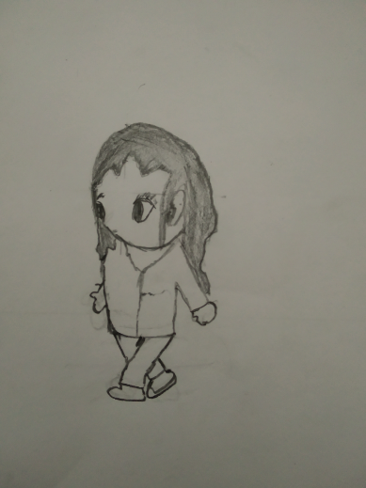 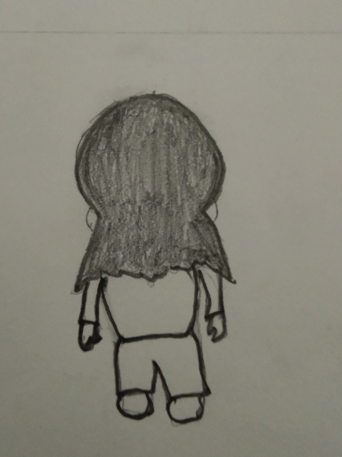

Left side back side

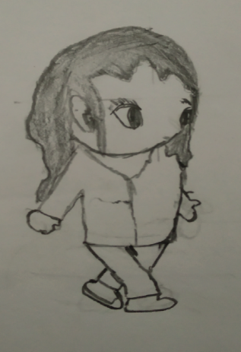 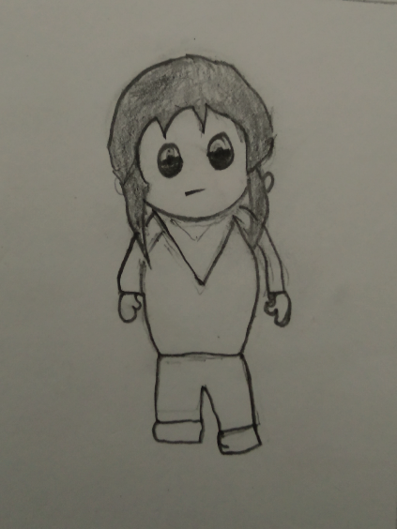

Right side front side

Background:

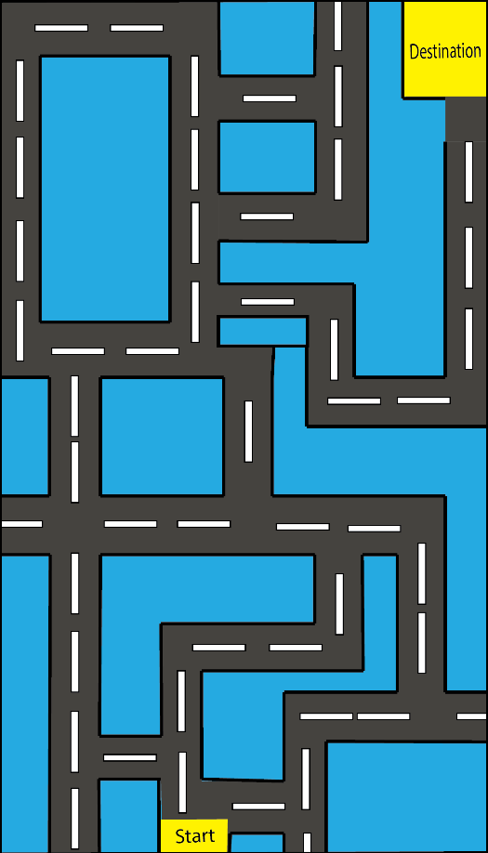

The game will start from the start point, and the player chareter will win the game when reach the destination.

Character profile worksheet:

Name : Hendrie

Age : 16

Gender : Male

Nationality : Bangladeshi

Hometown : A small village in Bangladesh

Current resident : Lost in a jungle

Socioeconomic level as a child: Middle class

Occupation : Student

Siblings : His friends

Relationship skills : He is a very good friend

Skills : Expert explanation of the mystery

Physical appearance:

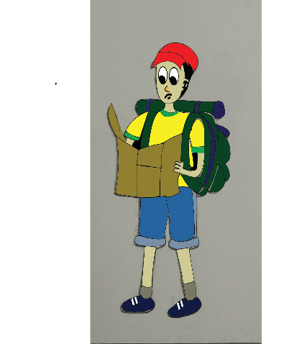

Body type : Tall and slim body

Height : 5.2”

Weight : 45 kg

Race : Bangladeshi

Hair color : Black

Eye color : Black

Skin tone : Fair

Shape of face : Oval shape face

Shape of body : Thin body

Hobbies : Traveling

Costume : Yellow t-shirt , blue pent , blue color shoe, , a red cap and a shoulder bag

Style : Very friendly

Signature pose : Walking with a map and a shoulder bag.

Intellectual / mental / personality / attitude:

Educational background : High school level

Character long time goal : Rescue his friends and other person who trapped there.

How does the character see himself : As a revolutionary

How self-confident is the character : Determined

How the character involve in the story : As his friends lost in

the jungle

Character role in the story : Protagonist

Prop design

1. **Map**

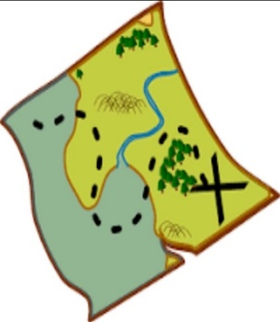

There are many types of map. In every level the map will changed. In every higher level Maps will be difficult.

* ***Coins***

*** ***

***Blue coin gold coin***

These are the coins. Through this coin player can update his levels and update the player also. He can also buy some rewards like shelter or he can buy his life. Blue coins value is 5 and gold coin value is 10.

* **Shield**



If he collects 500 coins without losing a life, then it will be reward for him. It can protect the player from losing life when he collusion with obstacle.

* **Win logo:**

 

When the player will win the game the win logo will appeared

**Gameplay:**

* In finding destination, the player will prefer to go a street. While the character is running, the player can swipe left or right to the character to either side of the screen to collect different type of reward or avoid obstacles.
* There are three type of reward

1. Increase 1o second time
2. Show the map again
3. Gather gold coins

* The gold coin can be used to upgrade the level of the character or buy reward and life
* When the player needs to turn left or right, the touchscreen can be swiped in the corresponding wishes to jump over an object, the screen can be swipe upwards; if the player wishes to slide under an object, the screen can be swiped downwards.
* If the player cannot reach the destination in time the game will over and if he falls in a hole or stuck somewhere then the game will be over or he can use his life to start the game again from there.
* There will be 3 lives at one level. If he falls or stumbles, then he loses a live. Or he loses 3 lives then the game will be over.
* If he collects 1000 coins he can buy a live for him
* If he collects 500 coins he can buy a shield
* If he collects 500 coins he can saw the map for 15 second during the game
* If the player goes to the wrong way, he will come to the starting point.

**Game play audio sounds:**

* **Menu sound:** when the player opens the menu then the sound will ring
* **Game play sound:** when the player will play the game then the sound will ring
* **Coin pick up sound:** when the player character collect coins then the sound will play
* **Walking sound:** when the player character walk the sound will play
* **Jump sound:** when the player character jump the sound will play
* **Final game fail sound:** when the player character lose the sound will play

**# When the player character stops no sound will play**

**Structure:**

**Game Difficulty:** S-curve

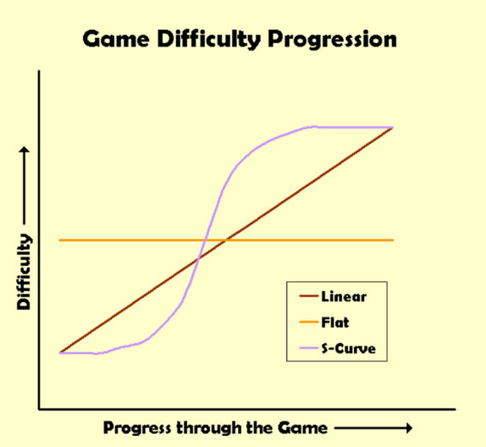

Difficulty in every level of the game will increase and decrease.

***Usability:*** It’s an auto save game. The player can start playing the game from where he ends the game

***Rules:***

* Once the time is over, he will not be able to play the game. He has to start from the beginning again.
* The player will not be able to see the map again after the game start.
* The player must take the map carefully before the game starts***.***

***Challenge***

Here are some challenges like the picture

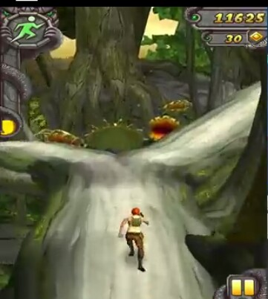 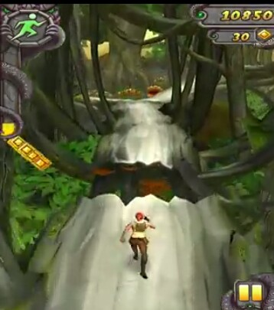

* There are some canals in the street that will have to jump over them
* Suddenly any tree can be broken, he had to be scrolled
* The trickster may have to make his way to the wrong direction.
* he will be given a specific time, and at that time he had to reach the destination.
* He must remember the map at the beginning of the game
* Collect a fixed amount of coin
* Reaching destination time will increase and decrease according to the level.

***Challenge difficulty***

* **Mission**: Find out all his friend and release them.
* **Sub mission**: Follow the map and reach destination.
* **Atomic challenge**: Jump over the canal and broken street.

***Balance***

* When he doing good in the difficult challenges he will get a reward.

***Reward like*** 1. Extra coins

2. He can see the map again for 15 second

3. He can get a reward that can help him cross the big canal or fly over it

***Victory conditions:***

* Find the destination in time or before time
* Recue the people from there

***Core Gameplay***

When there is a difficult challenge like this image in the game, then the game will be core gameplay

. 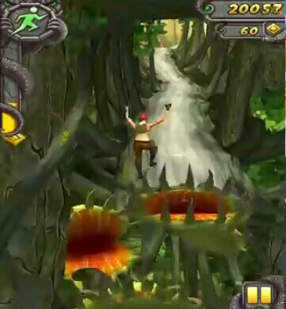

Mechanics:

**Running**  : Toreach the destination in time he has to run.

**Jumping :** Leaping over such canal



**Laying down**: When a tree breaks down, he must be rolled down the tree.

**Core mechanics:**

**High jump:** In this game high jump is core mechanics. Jump over such difficult canal is the core mechanics.

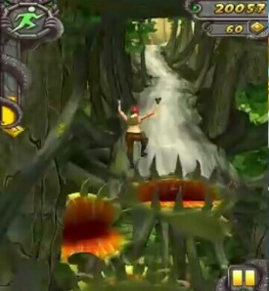

**Level design:**

**Level 1**

Level 1 is tutorial level. In this level player can understand the gameplay. What he has to do or how can he do so. In this level, a simple map will be shown to him for 15 second. He will get a minute to reach the destination according the map. And he needs to collect 100 coins also. If he does so then the level will have accomplished.

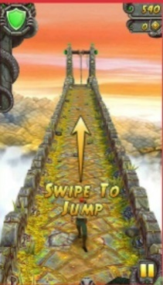 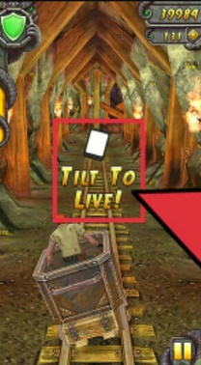

**Level 2:**

In this level player will get 1 minute to reach the destination. In this level he will face some small problems. Like jump over a small canal. And he needs to collects 300 coins. At the end he has to solve a small puzzle.

***Level 3:***

In level 3, he will get 1.5 minute to complete the level. Because in this level the map will be little difficult. And he will face more small problems. Like, suddenly a tree will break down. To save himself he need to scroll under the tree. And he needs to collect 500 coins also. At the end of the destination he has to find a key to unlock next level.

Level 4:

In this level, Game will be the same but he needs to collects 1000 coins. And he doesn’t need to find a key to unlock level.

Level 5:

In level 5 he will face a big challenge like he needs to jump over a big canal. If he completes the challenge he will get a reward like extra 100 coins.

Level 6:

In level 6 he needs to collect 2000 coins without losing a live. If he fails to do so the game will over. And maps will be more difficult from this level but time will be the same.

Level 7:

In level 7 challenges will be the same but time will decrease. He will get 1 minute to find the destination. In this level at the end he needs to solve a little difficult puzzle to find a key of a surprise gift box. If he failed, he won’t get the gift.

Level 8:

In this level he needs to gather 800 coins, if he can’t then the game will be over. And he has to face core gameplay in this level. If he completes the challenge he will find a friend of him.

Level 9:

Like the previous levels, gameplay will be more difficult. In this level, he can saw the map only for 10 seconds and he have to find the destination in 1.5 minute. He will also face core gameplay.

Level 10:

In level 10, he needs to rescue two friends at a time. And he also needs to collect 1000 coins. He can’t lose any life in this level. If he loses he can’t find his friends and he can’t also complete the challenge.

As like this; the game will continue till 20 levels.

Player can apply all the power he archived from previous levels. If the player can complete the given challenges he will win the game.

User Interface:

 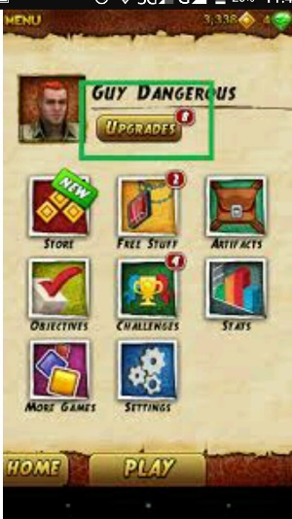

1. Play: player can start the game with the play option
2. Menu:
3. Upgrade level
4. Store
5. Free stuff
6. More games
7. Challenges
8. Home
9. Play